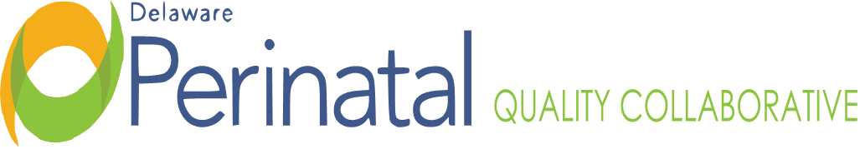
Date: September 25, 2023
PEDS TEAM MEETING
Location: Zoom Conference Call

MEMBER ATTENDANCE:
David Paul, MD, Co-Chair, CCHS Sarah Knavel, Bayhealth
Nancy Forsyth, Co-Chair, Beebe ☑ Jessica Alvarez, Bayhealth
☑ Garrett Colmorgen, MD, Chair DPQC Wendy McGee, Bayhealth
Kim Liprie ☑ Diane Hitchens, Tidal Health
☑ Joanna Costa, MD, Nemours Lisa Klein, MCDRC
Nancy Petit, MD, SF Vik Vishnubhakta
☑ David Hack, MD, SF ☑Mawuna Gardesey
☑ Samantha Carrier, Beebe ☑ Pam Kelly, SF
Dara Hall, Delaware First Health ☑ Kim York, Highmark
Michelle Olkkola, CCHS Pam Laymon, Bayhealth
☑ Megan Coalson, Amerihealth ☑ Liz Zehner, Beebe
☑ Heather Gabriel, Tidal Health Shelby Coon, Beebe
☑ Janet Dutcher, SF ☑ Bridget Buckaloo
☑ Meena Ramakrishnan ☑ Deb Allen
Anna Merrick, Beebe Alethea Miller, DMMA

FACILITATORS:
Dr. Nancy Forsyth
Dr. David Paul

TOPIC | FINDINGS, CONCLUSIONS & RECOMMENDATIONS | ACTIONS | STATUS
I. Call to order | The meeting was called to order by Dr. David Paul at 3:30p.m. | No further action. | Resolved
II. Minutes | Minutes of the September 25, 2023, meeting were approved. | No further action | Resolved
III. Healthy Soft | It is known that adequate and accurate data is not presently being captured in Healthy Soft. This should be an automatic upload of routine hospital discharge data. It may be an issue of coding and how neonatal abstinence syndrome is being coded by each hospital. | On-going | On-going
IV. Updates | Bridget reached out to SAMSHA for a grant funded stated ESC educational day. There is long application process this, will follow up on status. Alethea Miller with DMMA will investigate avenues of grant funding to educate nursing staff on ESC. | On-going | On-going
V. ESC | SF: Formed ESC task force; building 2 new rooms for NOWS; exploring central monitoring; developing ESC educational materials for parents; developing process for prenatal consults to educate families. Task Force met week and half ago, algorithm developed, and policy needs finalized, and developing consultation process with Nemours.  Bayhealth: Onboarding and increasing cuddlers; ESC key stakeholder meeting being planned.  Beebe: developed NOWS Task Force who is working on algorithm; Working on nursing education; and things progressing well.  CCHS: in January will start PRN dosing.  Tidal- Not at meeting | On-going | On-going
VI. Adjournment | There being no further items, the meeting adjourned at 4:16p.m. | No further action | Resolved
Minutes prepared by JoEllen Kimmey, DPH
Upcoming Meetings:
November 27, 2023, 3:30pm-4:30pm

