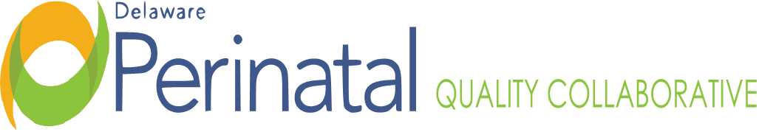
Date: July 24, 2023
PEDS TEAM MEETING
Location: Zoom Conference Call

MEMBER ATTENDANCE:
☑ David Paul, MD, Co-Chair, CCHS Sarah Knavel, Bayhealth
☑ Nancy Forsyth, Co-Chair, Beebe Jessica Alvarez, Bayhealth
Garrett Colmorgen, MD, Chair DPQC ☑ Wendy McGee, Bayhealth
Kim Liprie Diane Hitchens, Tidal Health
Joanna Costa, MD, Nemours Lisa Klein, MCDRC
Nancy Petit, MD, SF Mary Wise
David Hack, MD, SF ☑Mawuna Gardesey
☑ Samantha Carrier, Beebe ☑ Pam Kelly, SF
Dara Hall, Delaware First Health Kim York, Highmark
Michelle Olkkola, CCHS Pam Laymon, Bayhealth
Megan Coalson, Amerihealth ☑ Liz Zehner, Beebe
☑ Heather Gabriel, Tidal Health ☑ Shelby Coon
☑ Janet Dutcher, SF Bridget Buckaloo
Meena Ramakrishnan Deb Allen

FACILITATORS:
Dr. Nancy Forsyth
Dr. David Paul

TOPIC | FINDINGS, CONCLUSIONS & RECOMMENDATIONS | ACTIONS | STATUS
I. Call to order | The meeting was called to order by Dr. David Paul at 3:30p.m. | No further action. | Resolved
II. ESC/ LOS | Tidal Health: Is working on order sets ad policies.  Beebe: Is working on integration of ESC into their EMR and doing staff education.  SF: Had a meeting last week with members of their task force to inalize policy and received a grant to establish rooms where babies and mom can stay.  Bayhealth: Working to get cuddler program up and running in preparation for ESC and hoping for fall/ winter rollout. | On-going | On-going
III. Healthy Soft Data | Discharge data from 2021 reviewed for NAS, reported 135 out of 9,380 babies but many feel this is inaccurate and a low report. Healthy. Soft data depends on ICD-10 coding to be captured. Dr. Paul to discuss with Khaleel. | On-going | On-going
VI. Adjournment | There being no further items, the meeting adjourned at 4:00p.m. | No further action | Resolved
Minutes prepared by JoEllen Kimmey, DPH
Upcoming Meetings:
September 25, 2023, 3:30pm-4:30pm

