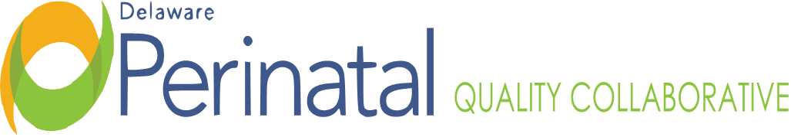

Date: | December 11, 2023
Medical Dir.: | Garrett Colmorgen, M.D.
Location: | Hilton Garden Inn, Capital Room, 1706 N. Dupont Highway, Dover, DE 19901

MEMBER ATTENDANCE:
Garrett Colmorgen, MCRC | Joanna Costa, Nemours | Kathleen McCarthy, Birthing Ctr.
Jessica Alvarez, Bayhealth  Bridget Buckaloo, Beebe  Margaret Chou, Nemours  Priscilla Mpasi, DHMIC  Marc Anthony Umobi, ACOG | Shamiya Gould, Consumer Adv.  Diane Hitchens, Tidal Health,  Kirk Reichard, AAP  Megan Williams, DEHA | Nancy Petit, SF,  Marilee Pinkleton CPM  Philip Schlossman, CCHS  David Hack, AAFP

FACILITATOR and DPH Representative:
Mawuna Gardesey, DPH

OTHER STAFF ATTENDANCE:
JoEllen Kimmey, DPH

TOPIC | FINDINGS, CONCLUSIONS & RECOMMENDATIONS | ACTIONS &  FOLLOW-UP | STATUS
I. Call to order and Welcome | The meeting was called to order by Dr. Colmorgen at 3:13p.m. | No further action required | Resolved
II. Review and Approval of Minutes | The minutes of the September 19, 2023, Annual DPQC and CDRC meeting were not approved as not enough members were in attendance for a quorum. | On-going | On-going
III. Demo of NNPQC Poster Presentation 12/6 in Denver | Bridget shared that she and Vik Vishnubhakta, data analysist to DPQC, attended the annual NNPQC in Denver last week and presented the poster on the Low Dose Aspirin Project. Delaware is doing a good job as far as PQC projects as the state is small. Many bigger states do not even have a maternal transport form or process in place. Each state was in attendance and did a poster presentation and Bridget and Vik were able to make connections with Rhode Island and D.C., both of whom are comprised of five birthing hospitals like Delaware. Many of the break-out sessions and the plenary sessions shared how they use MMRC data to inform their collaboratives and to address maternal opiate use. | No further action required. | Resolved
IV. Bylaws Discussion/ Approval/ Succession Plan | The Bylaws need to be voted on and approved before moving forward. There is issue with succession plan as Bylaws have officers serving a three-year term- Chairperson Elect/ Vice Chair; Chair; and Past Chairperson but many organizations have doctor’s only serving two terms (ACOG, etc.). This item needs further discussion and voting as to how to proceed. | On-going | On-going
V. Elect Officers | Chair: Dr. Colmorgen nominated on to serve as Chair  Vice-Chair: Kathleen McCarthy.  Voting will need to occur at next meeting, TBD via Zoom in January. | On-going | On-going
VI. Implicit Bias Training | DPQC has been charged with addressing Implicit Bias training in Delaware and needs to establish an Implicit Bias Workgroup but need quorum to establish this workgroup. More to come at next meeting. | On-going | On-going
VII. How can we accept funds moving forward? | There is issue with the DPQC accepting funds via AIM or another grant such HRSA. Mawuna is to propose a Budget Line Item to Legislature as AIM has a lot of funding to distribute but the DPQC has no mechanism to receive the dollars. | On-going | On-going
VIII. Next Steps | Discussion of how best to move forward for the biggest impact and how to take the DPQC initiatives directly to the communities, the community organizations, and the birthing persons to make a positive impact in Delaware.  There is a high need to have services in Delaware that address maternal substance use as this is the biggest reason that birthing women are dying in Delaware. Discussion of how DPQC could make connections on this issue in the communities.  Meetings for 2024 TBD and date of Board meeting in January to pass Bylaws and nominate officers TBD along with an RSVP feature to those meetings. | On-going | On-going
IX.. Adjournment | There being no further business before the Collaborative, the chair adjourned the meeting at 4:20pm. | No further action required | Resolved
Minutes prepared by J. Kimmey, DPH

Upcoming Quarterly Meetings of the DPQC Board:
Zoom Meeting TBD in January to pass Bylaws and vote on Chair and Chairperson Elect/ Vice Chair.

