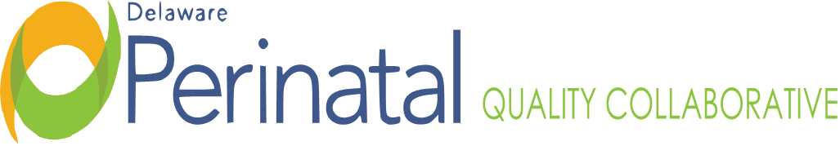
Date: September 25, 2023
PEDS TEAM MEETING
Location: Zoom Conference Call

MEMBER ATTENDANCE:
David Paul, MD, Co-Chair, CCHS Sarah Knavel, Bayhealth
Nancy Forsyth, Co-Chair, Beebe ☑ Jessica Alvarez, Bayhealth
☑ Garrett Colmorgen, MD, Chair DPQC Wendy McGee, Bayhealth
Kim Liprie ☑ Diane Hitchens, Tidal Health
☑ Joanna Costa, MD, Nemours Lisa Klein, MCDRC
Nancy Petit, MD, SF ☑ Mary Wise
☑ David Hack, MD, SF ☑Mawuna Gardesey
☑ Samantha Carrier, Beebe ☑ Pam Kelly, SF
Dara Hall, Delaware First Health ☑ Kim York, Highmark
☑ Michelle Olkkola, CCHS Pam Laymon, Bayhealth
Megan Coalson, Amerihealth ☑ Liz Zehner, Beebe
☑ Heather Gabriel, Tidal Health ☑ Shelby Coon
☑ Janet Dutcher, SF Bridget Buckaloo
Meena Ramakrishnan ☑ Deb Allen

FACILITATORS:
Dr. Nancy Forsyth
Dr. David Paul

TOPIC | FINDINGS, CONCLUSIONS & RECOMMENDATIONS | ACTIONS | STATUS
I. Call to order | The meeting was called to order by Dr. David Paul at 3:30p.m. | No further action. | Resolved
II. Healthy. Soft Data | In Healthy Soft the only thing available is the number of babies born, there are some issues with the NOWS data and accuracy in Healthy Soft. | On-going | On-going
III. ESC | At CCHS, had 150 NOWS and LOS has gone down by participating in. ESC. A second round of study is to begin soon and cuddlers are back.  SF: Has a pediatric team that follows ESC and a Task Force has been developed to look at this. Two rooms are designed for this, and construction is in place for mom and newborn. Remote monitoring is to be initiated with central monitoring in the nursery as funding is obtained. With the Nemours team they are developing good education program for the staff. This group is also developing training for the patients and family.  Bayhealth: Working on on-boarding of cuddlers; a meeting to be scheduled in October with all key stakeholders to discuss ESC implementation and timeline.  Beebe: NOWS Taskforce has been working on this process; have buy-in from administration and medical staff. Working with IT for assessment and documentation piece in Cerna and working on Nurse education. Working on framing the assessment in a positive, not negative way and shared their algorithm. Training to occur in October. | On-going | On-going
IV. Training- ESC | Will be looking into a training module or materials that could be shared statewide on ESC; possibility of an ESC champion for each facility or to host an education day. | On-going | On-going
V. Dr. Margaret Handy Lecture | On October 13, 2023, Leslie Young, one of the authors of the ESC study will be presenting at the Dr. Margaret Handy Annual Continuing Education Conference at CCHS. | On-going | On-going
VI. Adjournment | There being no further items, the meeting adjourned at 4:21p.m. | No further action | Resolved
Minutes prepared by JoEllen Kimmey, DPH
Upcoming Meetings:
October 23, 2023, 3:30pm-4:30pm
November 27, 2023, 3:30pm-4:30pm

