Social Determinants of Health Committee

November 27, 2023

Meeting Minutes
Location: Virtual Zoom
Attendees: 10 Participants. Ray Fitzgerald, Nick Beard, Michelle Statham, Devon Manning, Dabbah Maximore, Joan Kelley, Rep. Melissa Minor Brown, Mawuna Gardesey, Liddy Garcia Bunuel, Erin Nescott and Ana Bueno.
Liddy welcomed new Co-Chair Ray Fitzgerald and reviewed the agenda for the meeting.
Ray Fitzgerald introduced himself and all attendees introduced themselves.
Rep. Minor Brown welcomed new co-chair and members of the committee.
- Devon Manning, DSHA - Devon.Manning@delaware.gov
- Nick Beard, DCADV, nbeard@dcadv.org, 302-434-0046
- Dabbah Maximore, dabbah.maximore@delaware.gov - DSHA
- Michelle Statham (DSHA), michelle.statham@delaware.gov
- Erin Nescott, Center for Community Research and Service, Biden School of Public Policy and Administration, eplynch@udel.edu, 302.831.6780
- Joan Kelley, RN FIMR Program Coordinator under the MCDRC (Maternal & Child Death Review Commission). joan.kelley@delaware.gov/302-255-1766
- Mawuna Gardesey, DPH
Approval of Minutes September 12, 2023: Ray Fitzgerald moved a motion to approve the minutes for the September 12, 2023 meeting. Mawuna Gardesey moved a motion to approve the minutes. Michelle Stathan seconded the motion. Nick Beard abstained. Minutes were approved.
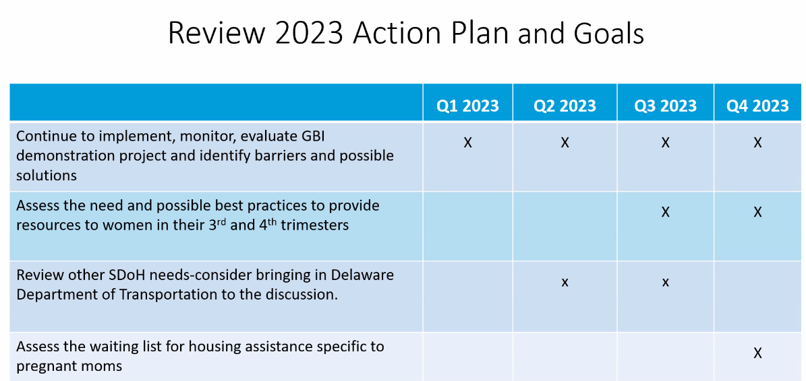
Review of 2023 Action Plan Goals: Liddy reviewed the action plans and goals and gave an update of the GBI program.

- Ray Fitzgerald added that in his project with Riverside there is a possibility create a pilot to link housing mimicking the GBI to provide free housing to do a along term research for people who participate.
- Rep. Minor Brown mentioned that it was not a bad idea as she felt that sometimes GBI is seen as money giving out easier and offering free housing would be easier to digest to have additional income for basic needs. ​
- Joan Kelley mentioned she felt that giving free housing may not empower participants and she felt it was important for participants to pay for some of the rent.
- Ray Fitzgerald suggested to possibly use the fees charged to participants to help them with downpayment to pay a house.
- Nick added that some issues of DV victims is hard for them to leave as there is a lot of financial control.
- Rep. Minor Brown added that it is important to have holistic approach to address the barriers wit financial education and making sure they have the resources they need including mental health support to make sure the clients are empowered, and they reach sustainability.
- Mawuna Gardesey mentioned that conversations like this one make the difference and helps the work move forward. Important to set up a process to make things happen and asked Ray to talk about benefit cliff.
- Ray Fitzgerald explained that having participants may risk the state benefits they receive. There is an opportunity to show that programs like this could help reduce benefit cliffs and use the resources more efficiently.
- Liddy reminded the committee members that for GBI participants looked at the impact on their benefits and gave consent to participate knowing the risks or how their benefits were going to change. She also added that empowering participants is very important and that having the liberty to choose how they spend their income helped participants learn how to manage their income.
- Erin added that in her research and she is willing to share the information she had gathered about the
Actions
Members agreed to focus on:
- Focus on Housing for women possibly collaborating with Wilmington Housing Alliance and Riverside and using a workgroup.
- Ray Added that using the Lease right model the demonstration program would not have impact on benefits.
- Explore and assess benefit cliff.
- Assessing housing assistance specific to pregnant moms. Ray suggested to do a robot call to participants asking if they are pregnant.

- Continue GBI and making sure participants transition properly after the 18-month demonstration program.
3rd and 4th trimester
Action
- Members agreed to move this to the Well Woman Committee
Transportation
- Members also agreed to focus on Housing for the next 12 months.
GBI Program
- Great results slide deck will be shared with the committee.
Next meeting agenda
- Erin will pull together and present information on Benefit Cliff
- Housing Discussion and plans for 2024
SDoH to meet quarterly.
- Housing Pilot Workgroup Monthly
Meeting adjourned at 10:00am

