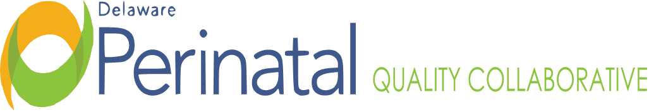
Date: December 21, 2023
Medical Dir.: Garrett Colmorgen, M.D.
Location: Zoom Conference Call

Monthly OB TEAM Membership Meeting

MEMBER ATTENDANCE:
Garrett Colmorgen, MD ☑ Kim Liprie ☑ Julia Paulus, CNM
Bridget Buckaloo, MSN, RN K. Starr Lynch, BSN, RN Nancy Petit, MD
☑ Christina Bryant ☑ Kathleen McCarthy, CNM, MSN Jennifer Pulcinella
☑ Joanna Costa, MD Jennifer Novack, MSN, RNC-OB, APN Philip Shlossman, MD
Mawuna Gardesey ☑ Rita Nutt ☑ Megan Williams, DHA
☑ David Hack, MD ☑David Paul, MD
Matthew Hoffman, MD
FACILITATOR:
Garrett Colmorgen, MD

OTHER STAFF ATTENDANCE:
Amanda Watson
Maria Webster
Vik Vashubhakta
Dara Hall
Michelle Olkkola
Deb Allen
Margaret Chou
Lisa Klein
Susan Todero
Mark Anthony Umobi

Cheryl Scott
Kim Hudson
Robin Revel
Erica Heilman
Pam Layman
Megan Coalson
Anne DeCaire
Liz Zehner
Marilee Pinkleton
Alethea Miller

TOPIC | FINDINGS, CONCLUSIONS & RECOMMENDATIONS | ACTIONS | STATUS
I. Call to order | The meeting was called to order by Dr. Colmorgen at 4:12pm due to technical difficulties. | No further action. | Resolved
II. NNPQC Meeting Report Out | Bridget shared that her and Vik Vishnubhakta, data analysist to DPQC, attended the annual NNPQC in Denver earlier this month and presented the poster on the Low Dose Aspirin Project. Delaware is doing a good job as far as PQC projects as the state is small. The women in Delaware are not dying from severe hypertension or time to treat but from drug overdose. This holds true across the country. Suggested that this be focus of DPQC for 2024. Some PCQ’s in other states were just established a few months ago and in other states were well established. Delaware is in the middle nationwide as far as our efforts. There was discussion of how to address SUD in mother’s and possible treatment referral solutions. Dara Hall shared some resources:  Home - Treatment Connection  Prevent. Treat. Recover. | Help is Here Delaware  The Delaware poster was shared to the group that was presented at the NNPQC. Alaska, DC and Georgia’s poster were shared as well and discussion what those regions are doing. | No further action. | Resolved
III. “Blue Bands” Project at Bayhealth Kent | “Blue Bands” is a way to identify patients who delivered in the past six weeks. Starr Lynch shared how Bayhealth Kent is working on this project.  The patient is to keep bracelet on until 6 weeks postpartum and  pink bracelet indicates pregnancy/ birth; white bracelet for people that have had a loss. Bracelets costs less than a dollar and this initiative could be presented in the protocol for statewide EMS training that will occur in February. This would assist if patient presented in emergency room as it would indicate patient recently had a birth and may have a different treatment protocol than a patient who had not recently delivered and if patient could not speak. This could become a statewide initiative and could be changed to any color that state decided on. | On-going | On-going
IV. Severe HTNNTTT Data Sheet | Vik shared that he contacted Alaska and DC on their initiatives and what worked for them. Each birthing hospital would provide aggregate data on month, birthing hospital, race/ ethnicity, among the denominator, number of patients who were treated within sixty minutes and the number of patients with persistent new onset severe HTN. This data could be uploaded into Healthy Soft monthly. This will be discussed further in January and could start in February. | On-going | On-going
V. Maternal Transport Discussion | This item will remain on the agenda for future meetings as to what each hospital is doing regarding maternal transports. CCHS has asked that all transfers coming into CCHS go through the CCHS Transport Center. Once accepted by Maternal/ Fetal Medicine, they take over and make sure there is a room, and it is three-way conversation with Transport Center, referring hospital and Maternal/ Fetal Medicine as to how patient will arrive- via ambulance or helicopter. | On-going | On-going
VI. Low Dose ASA Project | In October it was decided that the low dose aspirin data will continue to be collected. | On-going | On-going
VII. Using MMRC Data to Inform Work in 2024 MOUD | DPQC’s initiatives for 2024 will be guided by the data from MMRC and MOUD. | On-going | On-going
VIII. Announcements | Maternal Health Awareness Day will occur on January 27, 2024, in Kent or Sussex County. | On-going | On-going
IX. Adjournment | There being no further items, the meeting adjourned at 5:15pm. | No further action | Resolved
Minutes prepared by JoEllen Kimmey, DPH
Upcoming Meetings:
DPH is working to establish a better mechanism for virtual meeting links and invitations to upcoming meetings to follow in 2024.
DPQC Advisory Board Meeting: TBD
DPQC OB Team: Thursday, January 18, 2024 @ 4:00pm via ZOOM
DPQC PEDS Team: Monday, January 22, 2024 @ 3:30pm via ZOOM

