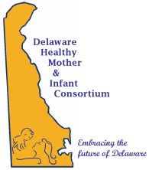
DELAWARE HEALTH AND SOCIAL SERVICES
Division of Public Health

Well Woman Committee and Black Maternal Health
Meeting Minutes

Date: September 12, 2023
Chair/Facilitators: Tiffany Chalk, Mona Liza Hamlin
Recorder: Leah Woodall, Chelsea Manwiller
Location: Delaware Technical Community College (Delaware Tech), Terry Campus, 100 Campus Dr, Dover, DE 19904, Del One Conference Room

Well Women Committee’s Primary Focus:
- Focuses on a comprehensive and evidence-based approach to reproductive health and the health of women before, during and between pregnancy
- Focused on a women centered, and clinician engaged care.

Black Maternal Health Workgroup’s Primary Focus:
- The Black Maternal Health Workgroup focuses on how to address the persistent maternal health disparities gap, by bringing awareness through grassroots organizations, educating consumers so educators and black women can have better outcomes before, during and between pregnancy.
- Focuses on maternal mental health as a current priority

Welcome and Introductions- Meeting was called to order by Mona Liza Hamlin around 9:06 am.

Michelle Mathew, Chelsea Manwiller, Erin Rideout, Bridget Buckaloo, Leah Woodall, Mona Liza Hamlin, Tiffany Chalk, Lisa Klein, Darra Hall, Nickee Alexander, LaToya Brathwaite-Washington, Jennifer Pulcinella, and Cynthia Guy.

Review of Minutes – All minutes will be posted at the following link: https://dethrives.com/dhmic/committees-and-workgroups/well-woman-black-woman-health-workgroup#upcoming-meetings

DHMIC Strategic Plan Goals and 1 Year Action Plan (listed below)
a. In the next 3-5 years, DHMIC would like to set the following aspirational goals:
b. The elimination of disparities between White, Black, and Hispanic infant and maternal mortality
c. The reduction of pre-term birthrate from 11% to less than 7% to be the lowest in the country.
d. The development of an innovative model of care that addresses both the health disparities and the reduction in pre-term births.

Well Woman 2023 Action Plan (listed below). Prioritize 3-5 SMART objectives to be accomplished over the next year.
- Develop an inventory of a maximum of 5 key meetings and gatherings that take place in DE related to the work of DHMIC and create a very specific plan for DHMIC's role and engagement with each, and how to share learnings and activity.
- Activate BMH workgroup community engagement arm to engage grassroots community members and listen to their voices.
- Work with schools and school-based health centers as a mode of connecting with youth and getting messages more upstream (consider working with universities and colleges as well).
- Promote access to evidence-based home visiting programs to ensure that women and families receive community-based support for prenatal and postpartum health and social support.
- Promote HWHBs program to engage high risk women residing in HWHBs High Risk Zones, and increase enrollment by 10% by 2024.
- Create consistent messaging in education and awareness using DEThrives social media and other channels, specifically surrounding women wellness issues, preconception care and where to find resources and support.
- Advance Life Course proficiency among Delaware's provider community and keep them engaged as partners and advocates for specific initiatives.
- Promote knowledge, skill and behavior change with regard to teen life planning.
See the Priority Matrix document below that was circulated during the meeting.
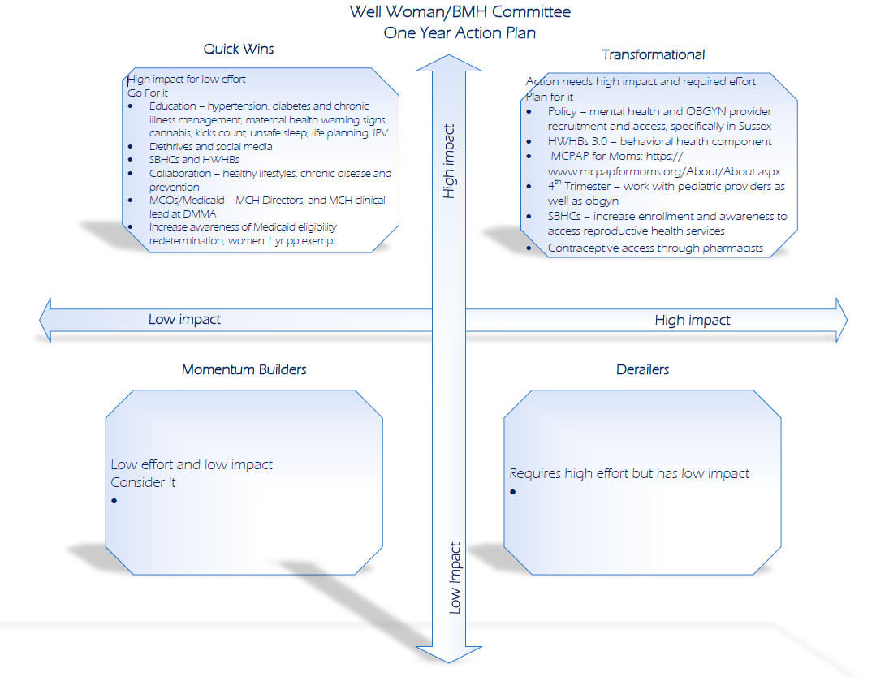
The top three themes the group decided upon included:
- Policy change
  - Address mental health
  - Need more OB-GYN provider community recruitment
  - Ideas:
    - Create a good recruitment plan for underserved areas
    - Bring nurse midwives into the picture to offer some assistance; state loan repayment or national health service corps programs
    - Look into the Women’s Health Caucus, Delaware ACOG, the Delaware Health Care Commission (DHCC), The Birth Center, Association of Women’s Health, Obstetric and Neonatal Nurses (AWHONN) partnerships, and DMMA Accountable Care (ACOs)
    - Connect with doulas
    - Managed Care Organizations (MCOs) could relay insurance coverage options during the Well Woman visits in preparation before baby arrives
    - Get the HWHB Providers and Community Health Workers (CHWs) involved with the below messaging and education (stated in #3) during community events
  - Issues:
    - Patients are not being seen during a certain timeframe to match their plan of care so clinics are losing patients
    - Healthcare commission needs to change their policy
    - Malpractice in the OB-GYN field. Patients can still sue their Provider years after they deliver a baby (18+ years after delivery).
    - There’s no incentive to open new practices
    - Complex cases cannot be seen by a midwife so the patient would have to be transferred to an OB-GYN in the end
- Address Fourth trimester care
  - Promote evidence-based Home Visiting services
    - In Pennsylvania, their HV program has a nurse that comes out every 3 months and visits the baby and mom to see if everything is okay which is covered by Medicaid.
    - Check in with mom after the delivery via HV services. Could be done through a telehealth visit.
  - Help establish a bridge/connection with mom and the PCP before baby arrives during the 2nd and 3rd trimester
  - Work with Pediatric and OB-GYN providers to address this timeframe for mothers during their baby’s visits – could address mental health topics during these scheduled checkups for the mother
  - Emphasize the importance of the postpartum visit
  - Educate and promote Medicaid one year postpartum coverage
  - Safe infant sleep practices and messaging based on AAP guidelines
  - Other wrap around support
  - Behavioral health support to women
  - Educate and promote the public and providers on Urgent Maternal Health Warning Signs
- Teen Life Planning and Increase enrollment and engagement with reproductive health services and support through well woman care. This will be done by messaging.
  - Focus on the 15-25 year old age range. Could use Teen Life Planning to reach this population as an example resource we could tap into.
    - Need to go back to the community and ask if this messaging is still relevant
  - Utilize Man Up Plan Up campaign and messaging
  - Utilize Teen Life Planning tools
    - Include sexual education and reproductive health messaging in schools so adolescents have a clear understanding of what to expect and when it will happen.
      - Don’t forget about sharing the dangers and risks associated with the LGBTQ+ community about sex education
  - Could maximize enrollment into HWHBs 3.0
  - Provide education about premature babies, don’t forget to include Sussex County with messaging
  - Include perinatal education
  - Provide education about preventive measures such as:
    - COPD
    - High blood pressure
    - Diabetes
    - Obesity
      - How the above affect wounds and infections
    - Substance use disorders (SUDs)
      - This is a modifiable SDOH but very difficult to address
        - Could we pick at the modifiable SDOH to improve other health outcomes?
    - Hospital level at the MCH level
    - Readmission rates

Goal for the next meeting: Look at the low impact and low effort category – “momentum Builders”. Look at the HWHB providers and see which benchmarks could be improved. Hone in on one theme and priority from the above choices that resonated with the committee and align with the DHMIC Strategic Plan. From this, we’ll discuss some strategies that would be impactful.

Announcements:

- September 20th, there is a Community Action Team
- LaToya Brathwaite-Washington shared an upcoming event “Say Her Name: Maternal Mortality Awanress 5K and Fair” event: https://www.instagram.com/p/Cw8xl_oN_s3/ which is scheduled on October 29th, 2023.

Adjournment: 10:15am

Next WW/BMH Combined Meeting will be held on Thursday, November 30th, 2023.

Other Business:

